Anthony Cunningham

Research Data Management

3/23/18

**Homework 4**

Problem 1

LIBNAME HW4 "H:\My SAS Files";

**DATA** subset_a subset_b;

SET HW4.Blood;

IF (WBC ne ".") AND (RBC ne ".") THEN combined = (**0.001**\*WBC) + RBC;

IF (Gender = "Female") AND (BloodType = "O") AND (combined ge **13**) THEN OUTPUT;

ELSE IF (Gender = "Female") AND (BloodType = "O") AND (combined lt **13**) THEN OUTPUT subset_a;

**RUN**;

**PROC** **PRINT** DATA = subset_a;

**RUN**;

**PROC** **PRINT** DATA = subset_b;

**RUN**;

* There are 208 observations in subset_a dataset, and 75 observations in subset_b dataset.

Problem 2

**DATA** markup;

INPUT Manuf : $10. markup;

DATALINES;

Cannondale 1.11

Trek 1.25

;

**RUN**;

**PROC** **SORT** DATA = HW4.Bicycles;

BY Manuf;

**RUN**;

**PROC** **SORT** DATA = markup;

BY Manuf;

**RUN**;

**DATA** markup_prices;

MERGE HW4.Bicycles markup;

BY Manuf;

newTotal = TotalSales*markup;

FORMAT newTotal DOLLAR7.0;

**RUN**;

**PROC** **PRINT** DATA = markup_prices;

**RUN**;

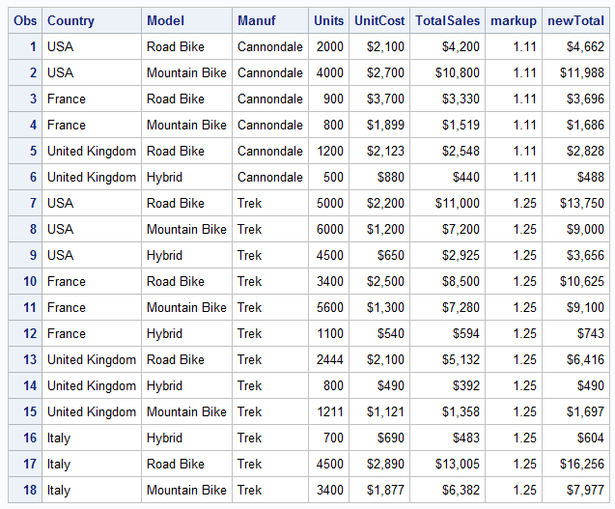

Problem 3

A.

**PROC** **SORT** DATA = mydata1;

BY a;

**RUN**;

**PROC** **SORT** DATA = mydata2;

BY c;

**RUN**;

**DATA** combine;

MERGE mydata1 mydata2 (RENAME=(c=a));

BY a;

**RUN**;

**PROC** **PRINT** DATA = combine;

**RUN**;

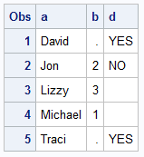

B.

**DATA** combine2;

MERGE mydata1 (IN=trackvar1) mydata2 (RENAME=(c=a) IN=trackvar2);

BY a;

IF trackvar1 AND trackvar2;

**RUN**;

**PROC** **PRINT** DATA = combine2;

**RUN**;

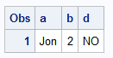

C.

**DATA** combine3;

MERGE mydata1 (IN=trackvar1) mydata2 (RENAME=(c=a) IN=trackvar2);

BY a;

IF trackvar1 AND trackvar2 THEN DELETE;

**RUN**;

**PROC** **PRINT** DATA = combine3;

**RUN**;

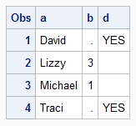

Problem 4

**DATA** survey_long;

SET HW4.survey;

ARRAY y2j {**5**} Ques1-Ques5;

DO qNum = **1** TO **5**;

question = y2j{qNum};

OUTPUT;

END;

DROP Ques1-Ques5 qNum;

**RUN**;

**PROC** **FREQ** DATA = survey_long;

TABLES question;

**RUN**;

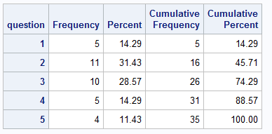

*There are 35 observations in dataset survey_long.